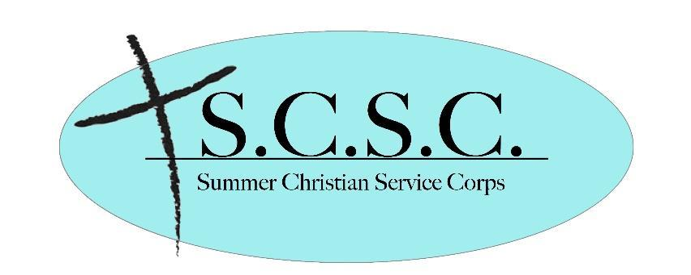
Dear Friends and Family,

This summer, I have the opportunity to participate in a servant-leadership training program, Summer Christian Service Corps (SCSC). This program is offered to young adults through the Seventh Day Baptist denomination.

SCSC is an opportunity which allows me to spend my summer serving a Seventh Day Baptist church. Following pre-training assignments of readings and written reflections, I will attend week-long intensive leadership and service training classes in Shiloh, NJ. After training, my teammate(s) and I will travel to our 4-week summer “project.” While “on project”, I will continue to develop my servant-leadership skills through hands-on experiences while working within the church’s summer programs. These can include prayer, teaching, worship, Bible studies, testimonies and evangelism as well as other ministries such as camp or Vacation Bible School. Throughout the summer I will be learning how to work cooperatively with my teammates, Project Director and others in the church and community. Finally, after four weeks “on project,” I will undergo an exit evaluation and prepare a final testimony from my summer experiences. I will then conclude my summer by participating in our annual denominational conference.

As you can imagine, there is a significant cost involved in this program. I am writing to you to ask for your support as I embark on this summer experience which will provide me with skills for a lifetime of service and leadership.

First and foremost, I ask for your prayer support. Please join with me in lifting up my project as well as the SCSC leaders, Project Directors and other students who will be serving this summer.

Secondly, I ask that you would prayerfully consider supporting this program with a financial contribution. Financial contributions must be postmarked by May 24th. Please do not send any financial support to me directly; it must go to this address, along with the tear-off slip below. Your check or money order can be sent to:
SCSC Support/S.D.B. Women’s Board P.O. Box 1678 Janesville, WI 53547-1678

In His Service,
Dear SCSC Committee:
I would like to partner with ___________________ (designee) in support of the SCSC program this summer.
Donor’s Name: ___________________________________________________________
Address: _________________________________________________________________________________
_________________________________________________________________________________________
□ Enclosed is my gift of $___________ to help this program continue.

Make check payable to SCSC Support/SDB Women’s Board. Please do not put the student’s name on the check “To” or memo line. Their name on this accompanying note will suffice for our fundraising records, and keep this donation eligible for your taxes as a charity donation. Thank you for your support of this program.

